# MACHINE LEARNING

**LAB WORK 8**

**NAME: CHETHAN Y**

**USN: 22BTRAD011**

**Implementing Panda**

**Code:**

#Implementing Pandas

import pandas as pd

# Creating a Pandas Series

series_data = pd.Series([10, 20, 30, 40])

print(series_data)

**Output:**

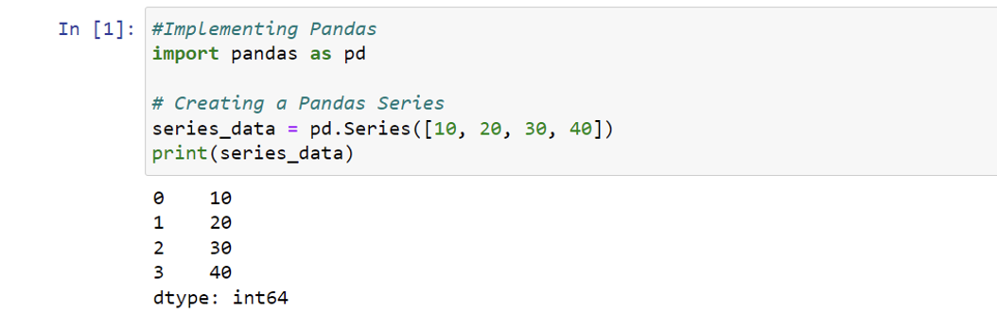

**Code:**

# Creating a Pandas DataFrame

data = {'Name': ['Alice', 'Bob', 'Charlie'],

'Age': [25, 30, 22]}

df = pd.DataFrame(data)

print(df)

**Output:**

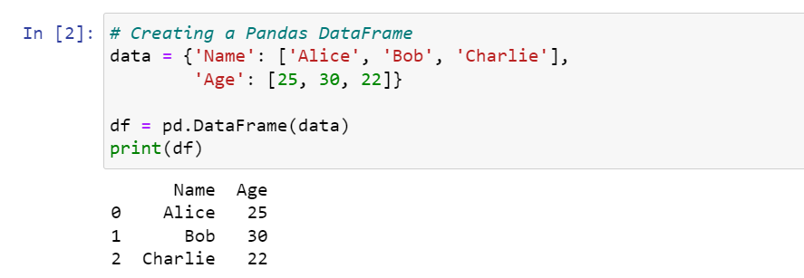

**Code:**

# Selecting a column by label

ages = df['Age']

print(ages)

# Selecting rows based on a condition

young_people = df[df['Age'] < 30]

print(young_people)

**Output:**

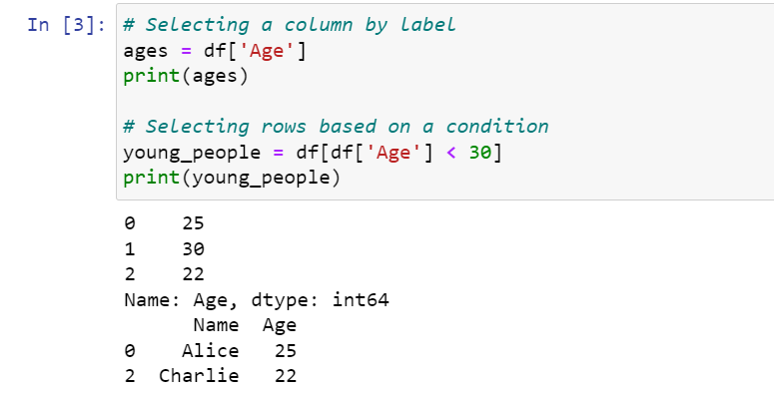

**Code:**

# Handling missing values

df.dropna() # Drop rows with missing values

df.fillna(5) # Fill missing values with a specified value

# Applying transformations

df['Age'] = df['Age'] + 1 # Incrementing ages by 1

print(df)

**Output:**

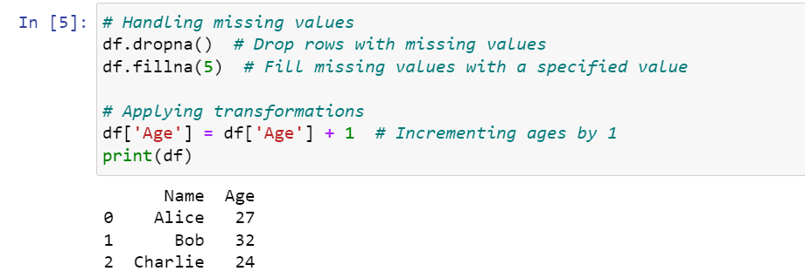

**Code:**

# Grouping by a column and calculating the mean

average_age_by_name = df.groupby('Name')['Age'].mean()

print(average_age_by_name)

**Output:**

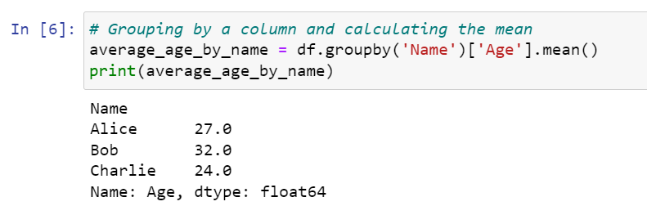

**Code:**

# Reading data from a CSV file

df = pd.read_csv('iris_csv.csv')

df.head()

**Output:**

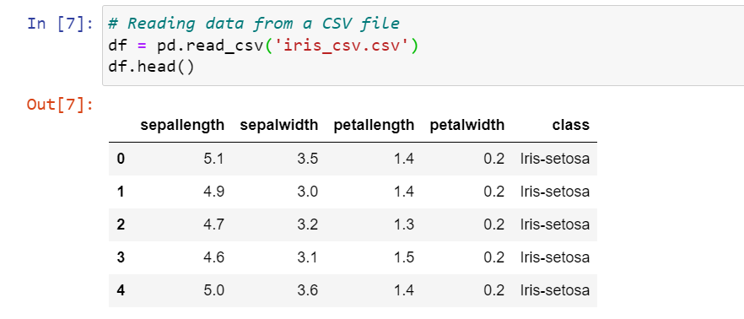

**GitHub Link:** **https://github.com/chethan1n1/machine-learning**